Time schedule
Monday - Thursday

Bus route: Metro Slavyansky Boulevard —Vereiskaya Plaza;
Vereiskaya Plaza — Metro Slavyansky Boulevard

Route number | MORNING |  |  |  |  | DAY |  |  | EVENING
 | Departure from Metro station |  |  |  |  | Departure from Plaza |  |  | Departure from Plaza
1 | 07:10 | 08:20 | 08:44 | 09:17 | 09:46 |  |  |  | 17:00 | 17:34 | 18:08 | 18:42 | 19:40
2 | 07:20 | 08:21 | 08:46 | 09:18 | 09:48 |  |  |  | 17:02 | 17:36 | 18:10 | 18:44 | 19:45
3 | 07:30 | 08:23 | 08:48 | 09:19 | 09:50 |  |  |  | 17:04 | 17:38 | 18:12 | 18:46 | 19:50
4 | 07:40 | 08:24 | 08:50 | 09:20 | 09:52 |  |  |  | 17:06 | 17:40 | 18:14 | 18:48 | 20:00
5 | 07:45 | 08:25 | 08:52 | 09:21 | 09:54 |  |  |  | 17:08 | 17:42 | 18:16 | 18:50 | 20:05
6 | 07:50 | 08:26 | 08:54 | 09:22 | 09:56 |  |  |  | 17:10 | 17:44 | 18:18 | 18:52 | 20:10
7 | 07:55 | 08:27 | 08:56 | 09:23 | 09:58 |  |  |  | 17:12 | 17:46 | 18:20 | 18:54 | 20:20
8 | 08:00 | 08:28 | 08:58 | 09:26 | 10:00 |  |  |  | 17:14 | 17:48 | 18:22 | 18:56 | 20:25
9 | 08:02 | 08:29 | 09:00 | 09:28 | 10:05 |  |  |  | 17:16 | 17:50 | 18:24 | 18:58 | 20:30
10 | 08:04 | 08:30 | 09:02 | 09:30 | 10:10 |  |  |  | 17:18 | 17:52 | 18:26 | 19:00
11 | 08:06 | 08:31 | 09:04 | 09:32 | 10:15 |  |  |  | 17:20 | 17:54 | 18:28 | 19:05
12 | 08:08 | 08:32 | 09:06 | 09:34 | 10:20 |  |  |  | 17:22 | 17:56 | 18:30 | 19:10
13 | 08:10 | 08:34 | 09:08 | 09:36 | 10:30 |  |  |  | 17:24 | 17:58 | 18:32 | 19:15
14 | 08:12 | 08:36 | 09:10 | 09:38 | 10:40 |  |  |  | 17:26 | 18:00 | 18:34 | 19:20
15 | 08:14 | 08:38 | 09:12 | 09:40 | 10:50 |  |  |  | 17:28 | 18:02 | 18:36 | 19:25
16 | 08:16 | 08:40 | 09:14 | 09:42 | 11:00 | 13:00 | 14:30 | 16:00 | 17:30 | 18:04 | 18:38 | 19:30
17 | 08:18 | 08:42 | 09:16 | 09:44 | 11:30 | 13:30 | 15:00 | 16:30 | 17:32 | 18:06 | 18:40 | 19:35

Time schedule
Friday

Bus route: Metro Slavyansky Boulevard —Vereiskaya Plaza;
Vereiskaya Plaza — Metro Slavyansky Boulevard

Route number | MORNING |  |  |  |  | DAY |  |  | EVENING
 | Departure from Metro station |  |  |  |  | Departure from Plaza |  |  | Departure from Plaza
1 | 07:10 | 08:20 | 08:44 | 09:17 | 09:46 |  |  |  | 16:40 | 17:14 | 17:48 | 18:22 | 18:56
2 | 07:20 | 08:21 | 08:46 | 09:18 | 09:48 |  |  |  | 16:42 | 17:16 | 17:50 | 18:24 | 18:58
3 | 07:30 | 08:23 | 08:48 | 09:19 | 09:50 |  |  |  | 16:44 | 17:18 | 17:52 | 18:26 | 19:00
4 | 07:40 | 08:24 | 08:50 | 09:20 | 09:52 |  |  |  | 16:46 | 17:20 | 17:54 | 18:28 | 19:10
5 | 07:45 | 08:25 | 08:52 | 09:21 | 09:54 |  |  |  | 16:48 | 17:22 | 17:56 | 18:30 | 19:25
6 | 07:50 | 08:26 | 08:54 | 09:22 | 09:56 |  |  |  | 16:50 | 17:24 | 17:58 | 18:32 | 19:40
7 | 07:55 | 08:27 | 08:56 | 09:23 | 09:58 |  |  |  | 16:52 | 17:26 | 18:00 | 18:34 | 19:55
8 | 08:00 | 08:28 | 08:58 | 09:26 | 10:00 |  |  |  | 16:54 | 17:28 | 18:02 | 18:36 | 20:15
9 | 08:02 | 08:29 | 09:00 | 09:28 | 10:05 |  |  |  | 16:56 | 17:30 | 18:04 | 18:38 | 20:30
10 | 08:04 | 08:30 | 09:02 | 09:30 | 10:10 |  |  |  | 16:58 | 17:32 | 18:06 | 18:40
11 | 08:06 | 08:31 | 09:04 | 09:32 | 10:15 |  |  |  | 17:00 | 17:34 | 18:08 | 18:42
12 | 08:08 | 08:32 | 09:06 | 09:34 | 10:20 |  |  |  | 17:02 | 17:36 | 18:10 | 18:44
13 | 08:10 | 08:34 | 09:08 | 09:36 | 10:30 |  |  |  | 17:04 | 17:38 | 18:12 | 18:46
14 | 08:12 | 08:36 | 09:10 | 09:38 | 10:40 |  |  |  | 17:06 | 17:40 | 18:14 | 18:48
15 | 08:14 | 08:38 | 09:12 | 09:40 | 10:50 |  |  |  | 17:08 | 17:42 | 18:16 | 18:50
16 | 08:16 | 08:40 | 09:14 | 09:42 | 11:00 | 13:00 | 14:30 | 16:00 | 17:10 | 17:44 | 18:18 | 18:52
17 | 08:18 | 08:42 | 09:16 | 09:44 | 11:30 | 13:30 | 15:00 | 16:30 | 17:12 | 17:46 | 18:20 | 18:54

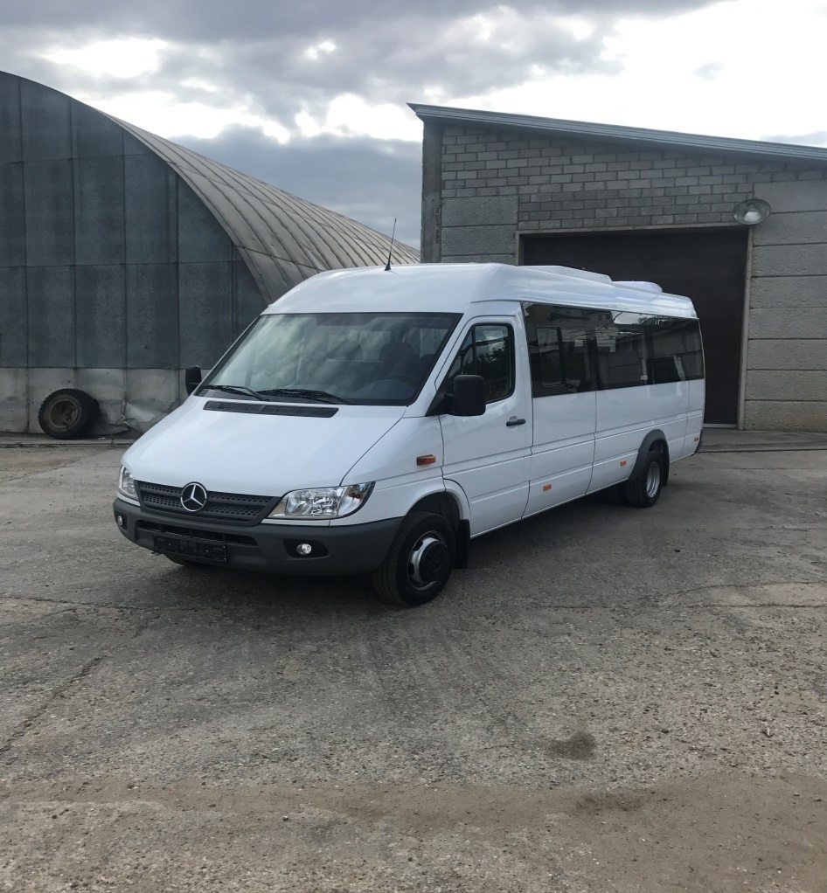

Mercedes Benz Sprinter, 20 seats, white-colored.

Dear tenants!
We are bringing to your attention that from August, 20 (Monday), 2018, in order to improve the quality of service for employees, on the plazas Vereiskaya 1,2,3 the transfer will be carried out by Mercedes Sprinter buses (white colored, 20 seats).
Buses are marked "Vereiskaya plaza" on the windshield.
The places of boarding and disembarking remain unchanged. Also, a new bus schedule is being introduced from the Slavyansky Boulevard to the Vereiskaya Plaza business center and back.
Please bring this information to the attention of your staff.
You can check the new schedule with the secretaries of your offices.

